**Question 2:**

HTML:  
<!DOCTYPE html>

<html lang="en">

<head>

    <meta charset="UTF-8">

    <meta http-equiv="X-UA-Compatible" content="IE=edge">

    <meta name="viewport" content="width=device-width, initial-scale=1.0">

    <title>Document</title>

</head>

<body>

 <script src="script1.js"></script>

</body>

</html>

**Java Script:**

var request=new XMLHttpRequest();

request.open("GET","https://raw.githubusercontent.com/rvsp/restcountries-json-data/master/res-countries.json");

request.send();

request.onload=function(){

    var data=JSON.parse(request.response);

    console.log(data);

    //console.log(data[0]);

    for(let i=0;i<=data.length;i++){

    console.log(`flag:${data[i].flag}`);

    }

**}**

**Output:**

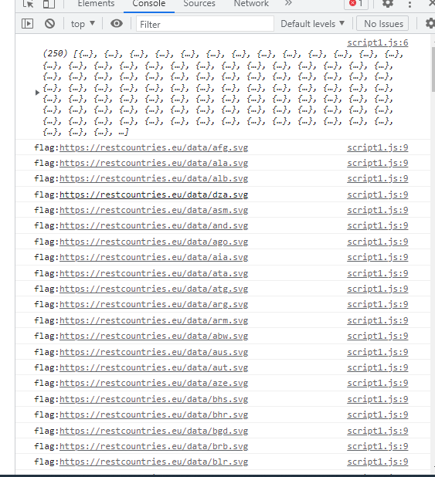

**Question 3:**

HTML:  
<!DOCTYPE html>

<html lang="en">

<head>

    <meta charset="UTF-8">

    <meta http-equiv="X-UA-Compatible" content="IE=edge">

    <meta name="viewport" content="width=device-width, initial-scale=1.0">

    <title>Document</title>

</head>

<body>

 <script src="script1.js"></script>

</body>

</html>

**Java script**

var request=new XMLHttpRequest();

request.open("GET","https://raw.githubusercontent.com/rvsp/restcountries-json-data/master/res-countries.json");

request.send();

request.onload=function(){

    var data=JSON.parse(request.response);

    console.log(data);

    //console.log(data[0]);

    for(let i=0;i<=data.length;i++){

        console.log(`Name:${data[i].name} region:${data[i].region} subregion:${data[i].subregion}`);

    }

    }

**Out put:**

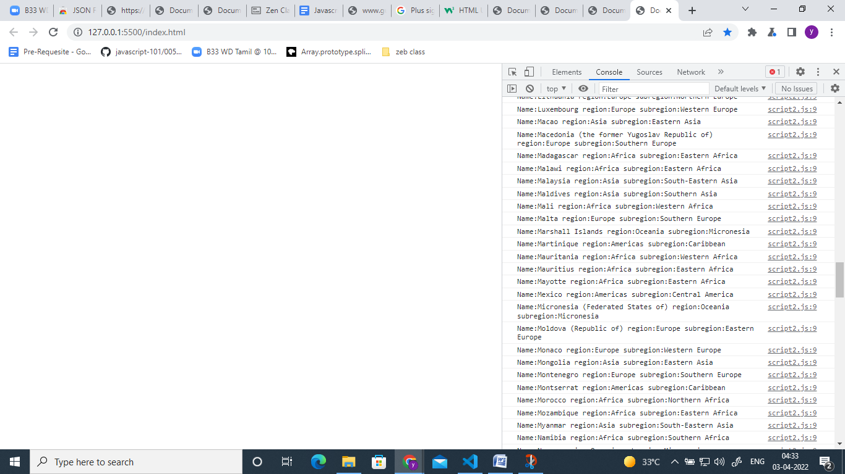

Question 4:

1. Declare four variables without assigning values and print them in console

var a;

var b;

var c;

var d;

console.log(a,b,c,d);

OutPut:

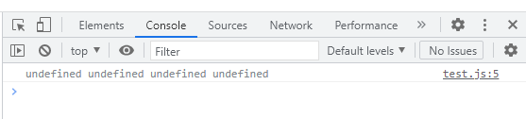

2) How to get value of the variable myvar as output

var myvar= 1;  
console.log("myvar");

output:

myvar

Because of myvar contain a string in console.log.

3)Declare variables to store your first name, last name, marital status, country and age in multiple line

var firstname ="yasodha";

var lastname ="kandasamy";

var maritalstatus="married";

var country="india";

let age = 29;

console.log(firstname);

console.log(lastname);

console.log(maritalstatus);

console.log(country);

console.log(age);

Out put:

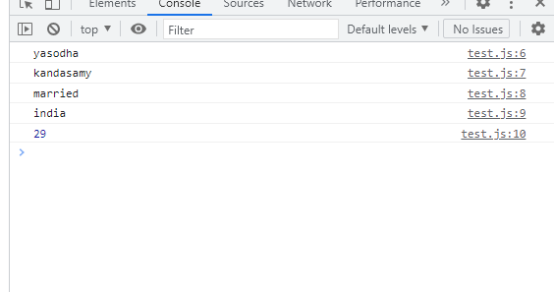

4)Declare variables to store your first name, last name, marital status, country and age in single line

var firstname ="yasodha";

var lastname ="kandasamy";

var maritalstatus="married";

var country="india";

let age = 29;

console.log(`firstname:${firstname} lastname:${lastname} maritalstatus:${maritalstatus} country:${country} age"${age}

`);

Output:

